**Homework 5**

Instructions

Set up a DHCP server on R4 (eth2) such that it leases IP addresses from the 10.10.11.X/28 subnet to the Ubuntu VM. Calculate the network, broadcast, and useable range of IP addresses for your address range. Select the first useable IP address as the static address for the R4 interface (remember that we cannot use the network and broadcast). The remaining addresses will go into the pool that the DHCP server will lease and manage.

Before starting this lab, please read RFC 2131.

**Note**: Please make any necessary changes to the /etc/network/interfaces file of Ubuntu before you proceed. The file should already have an existing entry for DHCP which includes:

iface eth0 inet dhcp

**Part 1: Configuring DHCP**

The first step is to configure the dhcpd.conf (DHCP daemon configuration) file in router R4. This file is present in the /etc/dhcp directory. You can make edits to this file using any text editor.

Consult the example configuration options in the dhcpd.conf file to configure your DHCP server on R4. Make sure to set default-lease-time to 300.

Note that you do not need to provide configurations for the option domain-name or domain name -servers.

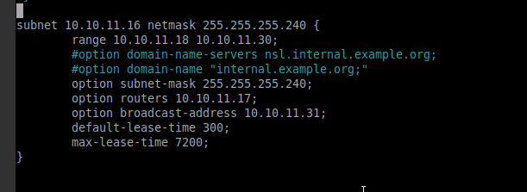

**Part 2: Server Interface**

Check *the /etc/default/isc-dhcp-server* file on R4. This file has to be changed so the DHCP server knows which interface it should listen on for serving IP addresses.

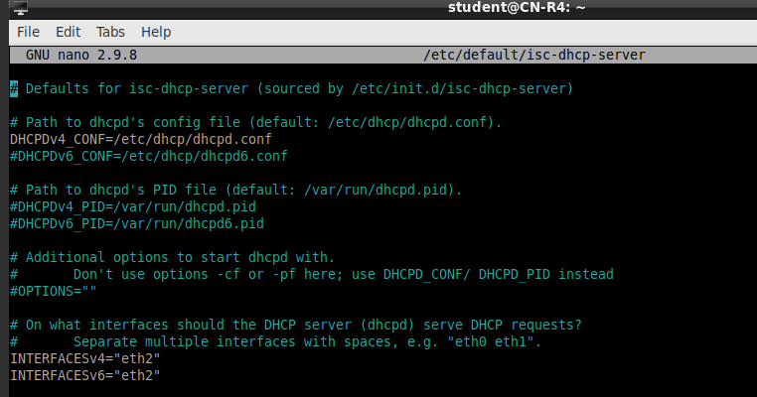

**Part 3: Verifying DHCP and Wireshark**

We will verify that Ubuntu has obtained an IP address.

1. Shutdown R4 and Ubuntu.

2. Power on Ubuntu and run Wireshark via the terminal: sudo wireshark

3. Monitor incoming traffic on the appropriate interface.

4. Now power on R4 and view Wireshark traffic on Ubuntu.

5. Use the following filter to show DHCP messages: udp.port == 67

6. Take a screenshot showing all captured DHCP messages.

Note: Verify that the DHCP server is running properly on R4 by using the following command:

sudo systemctl status isc-dhcp-server.service

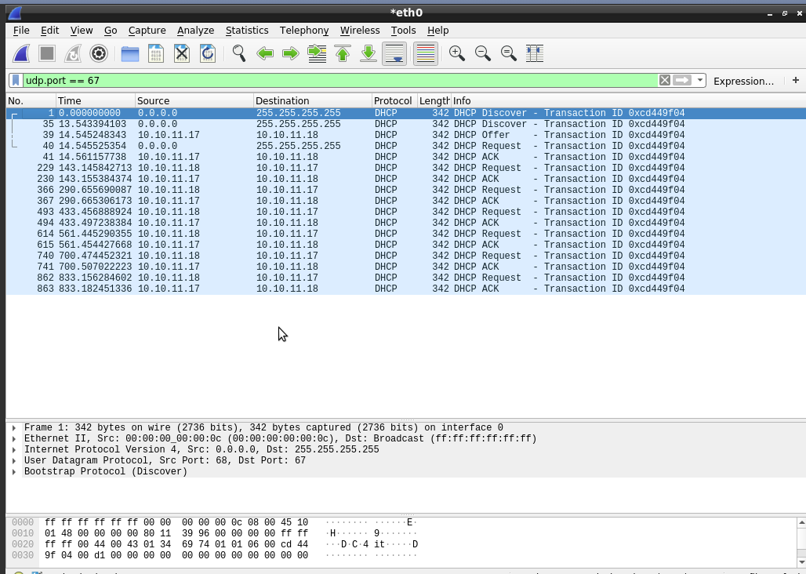

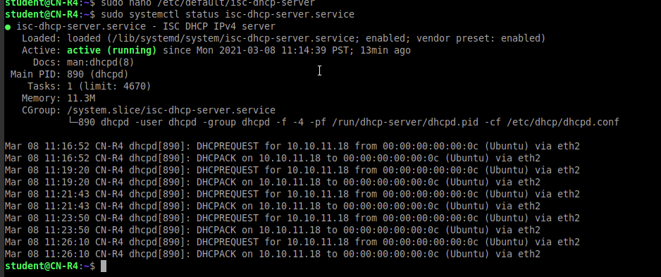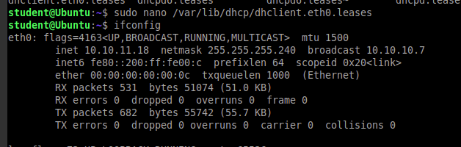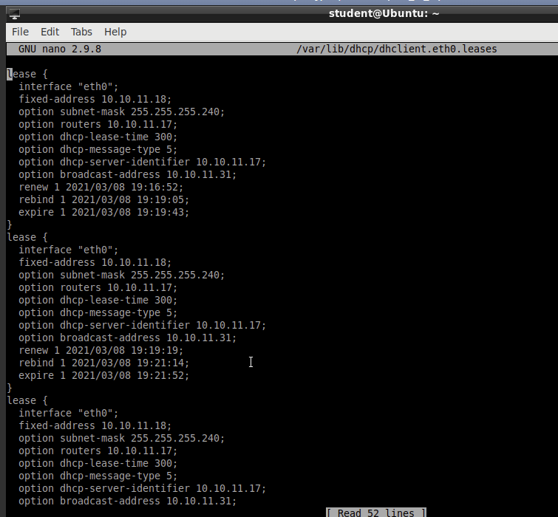

[20 points] The leases file on R4 found in /var/lib/dhcp/dhcpd.leases

DHCPD.leases on R4

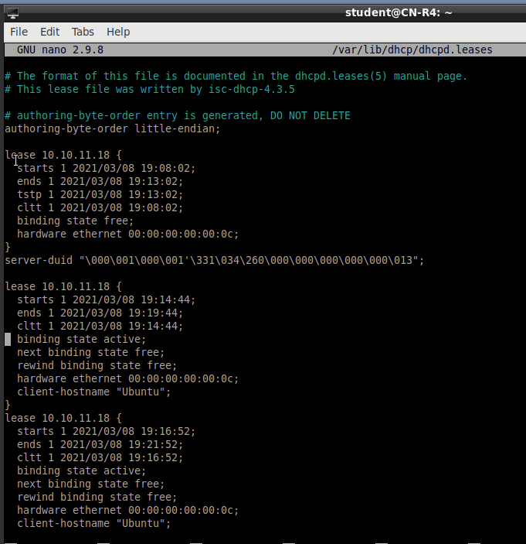

DHCP client lease on Ubuntu.

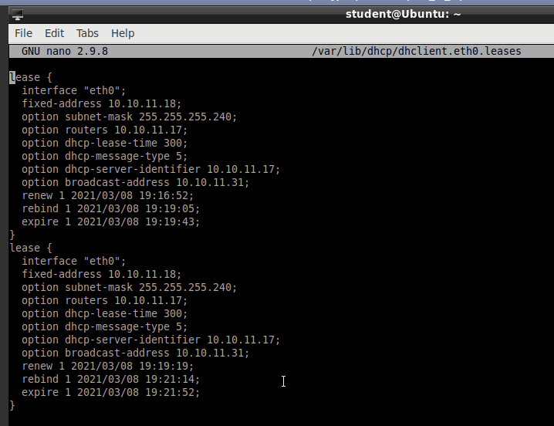

[20 points] Your configuration for the DHCP server.

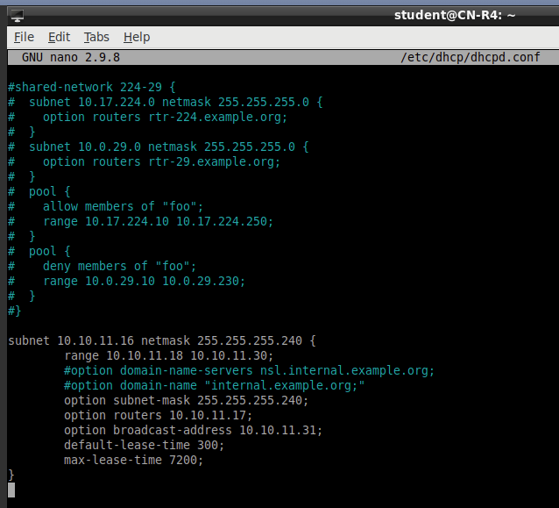

[20 points] Screenshot of ifconfig on Ubuntu.

Before R4 is powered on

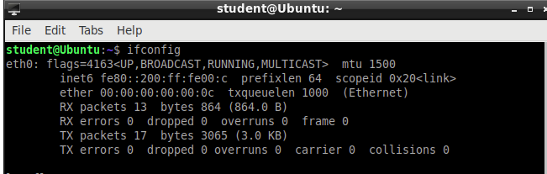

After R4 is powered on

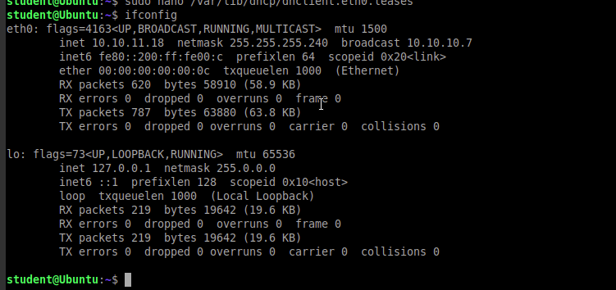

[20 points] Screenshot showing Ubuntu pinging R4

Pinging R4 on all 3 interfaces.

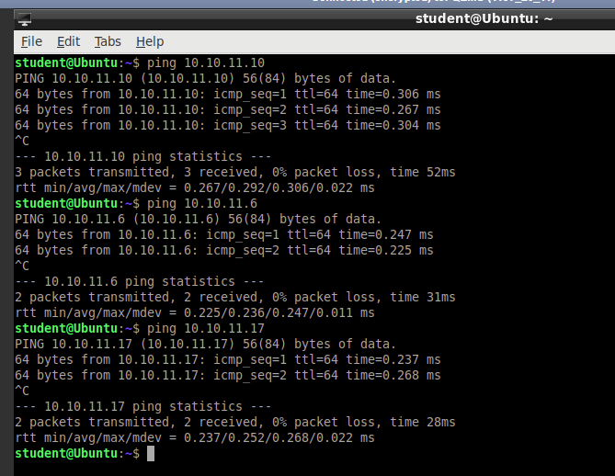

Ubuntu’s arp table

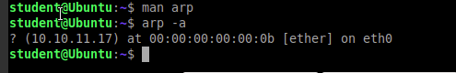

[20 points] Screenshot showing Wireshark DHCP messages (4 Types).

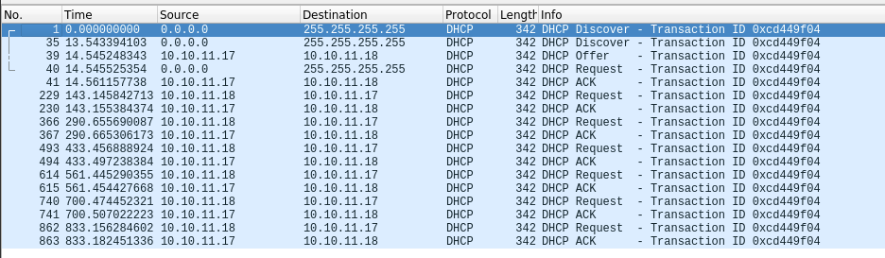

**DHCP Discover**-The Ubuntu client broadcasts this packet through its interface to discover what DHCP servers are in this network. This is sent towards destination 255.255.255.255 as the broadcast address and has the source as 0.0.0.0 because the Ubuntu client has no IP address.

**DHCP Offer**-After R4 receives the DHCP Discover message, it will reply to the Ubuntu client with a DHCP Offer message. The message contains an offer to use an IPv4 address with certain specifications, including what IP address can be leased and for how long, granted by the R4 DHCP server. These specifications come from the settings written into /etc/dhcp directory.

**DHCP Request Message** – Client replies to the DHCP Offer message by broadcasting the DHCP Offer specifications to the interface. Once R4 receives the message, R4 will know that the Ubuntu client wants to accept this offer. The message is broadcasted so that any other DHCP servers that sent a different offer will rescind their offer if the request message does not match their lease.

**DHCP ACK** – The R4 DHCP server sends an acknowledgement to the Ubuntu client to let the client confirm that the DHCP lease is now available to use until the client’s lease expires.